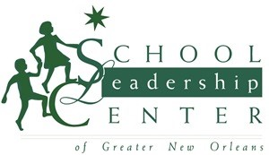
Fellows Leadership Retreat 2019
June 17-21, 2019
Join a community of school leaders for a full week of learning, collaboration, and fun! You will leave the retreat with research-based and data-driven plans for a successful 2019-20 school year, new friendships, and lots of innovative strategies to lead the learning at your school.
Monday  June 17 | Jill Jackson in New Orleans  Being the Lead Learner: Practical Steps to Instructional Leadership | Lunch and snacks included
Tuesday  June 18 | Jill Jackson in New Orleans  Being the Lead Learner: Practical Steps to Instructional Leadership | Lunch and snacks included
Wednesday  June 19 | Arrive at White House Hotel in Biloxi at 1:30  School Data Dive & Goal Setting | Hotel and dinner included
Thursday  June 20 | All Day at White House Hotel  Action Planning for a Successful School Year | All meals and hotel included
Friday  June 21 | Depart White House Hotel at 10:30 am  Motivation & Graduation | Breakfast included

Cost: $3,400

SLC Fellows Program
2019 Summer Institute Registration

Current Position/Title_________________________________________________
Current School & District______________________________________________
Email Address_______________________________________________________
School Address______________________________________________________
School Phone_______________________ Cell Phone______________________

I will be attending SLC’s 2019 Summer Institute
I would like more information about SLC’s 2019 Summer Institute

Please complete and email to Sraphael@SLC-GNO.org

